Test – Copywrite symbol removal.
Before running headers:
New File created in repo without headers.
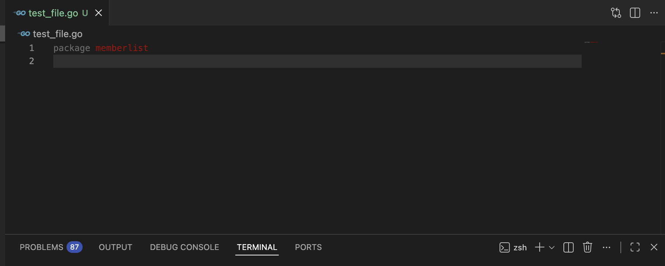
After running headers command:
Copyright statement added without symbol.
